- Install docker on your server
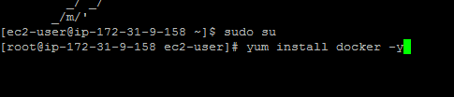
- Create docker, Requirement & App file
- vi Dockerfile
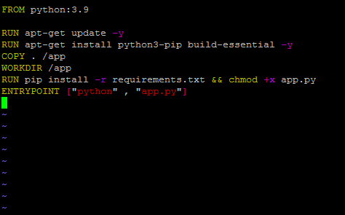
- vi requirements.txt
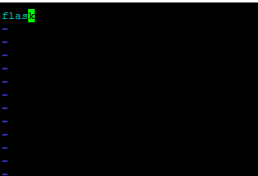
- vi app.py
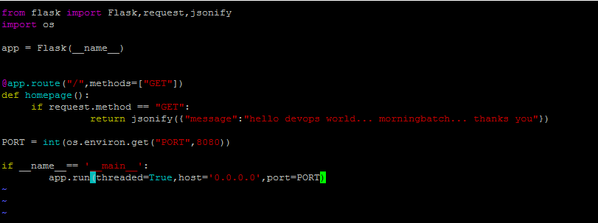
- Create image from Docker file
- Docker build -t image .
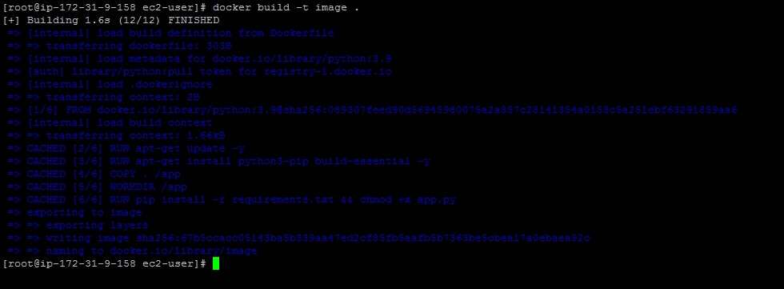
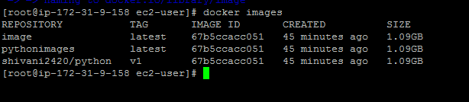

- Create container from image

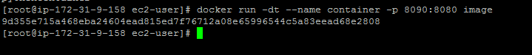

- Output (http://3.111.30.24:8090)

